Lab 7 Linear Regression Trends
Jordan Beaird
HSC 4933
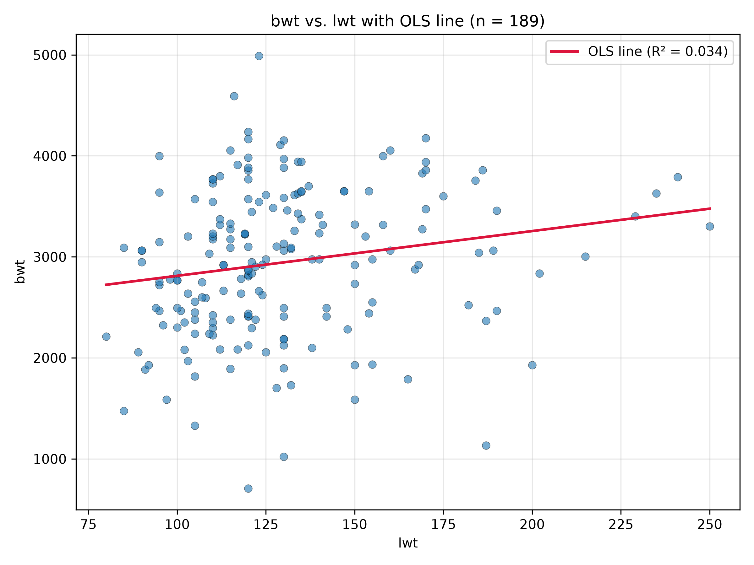
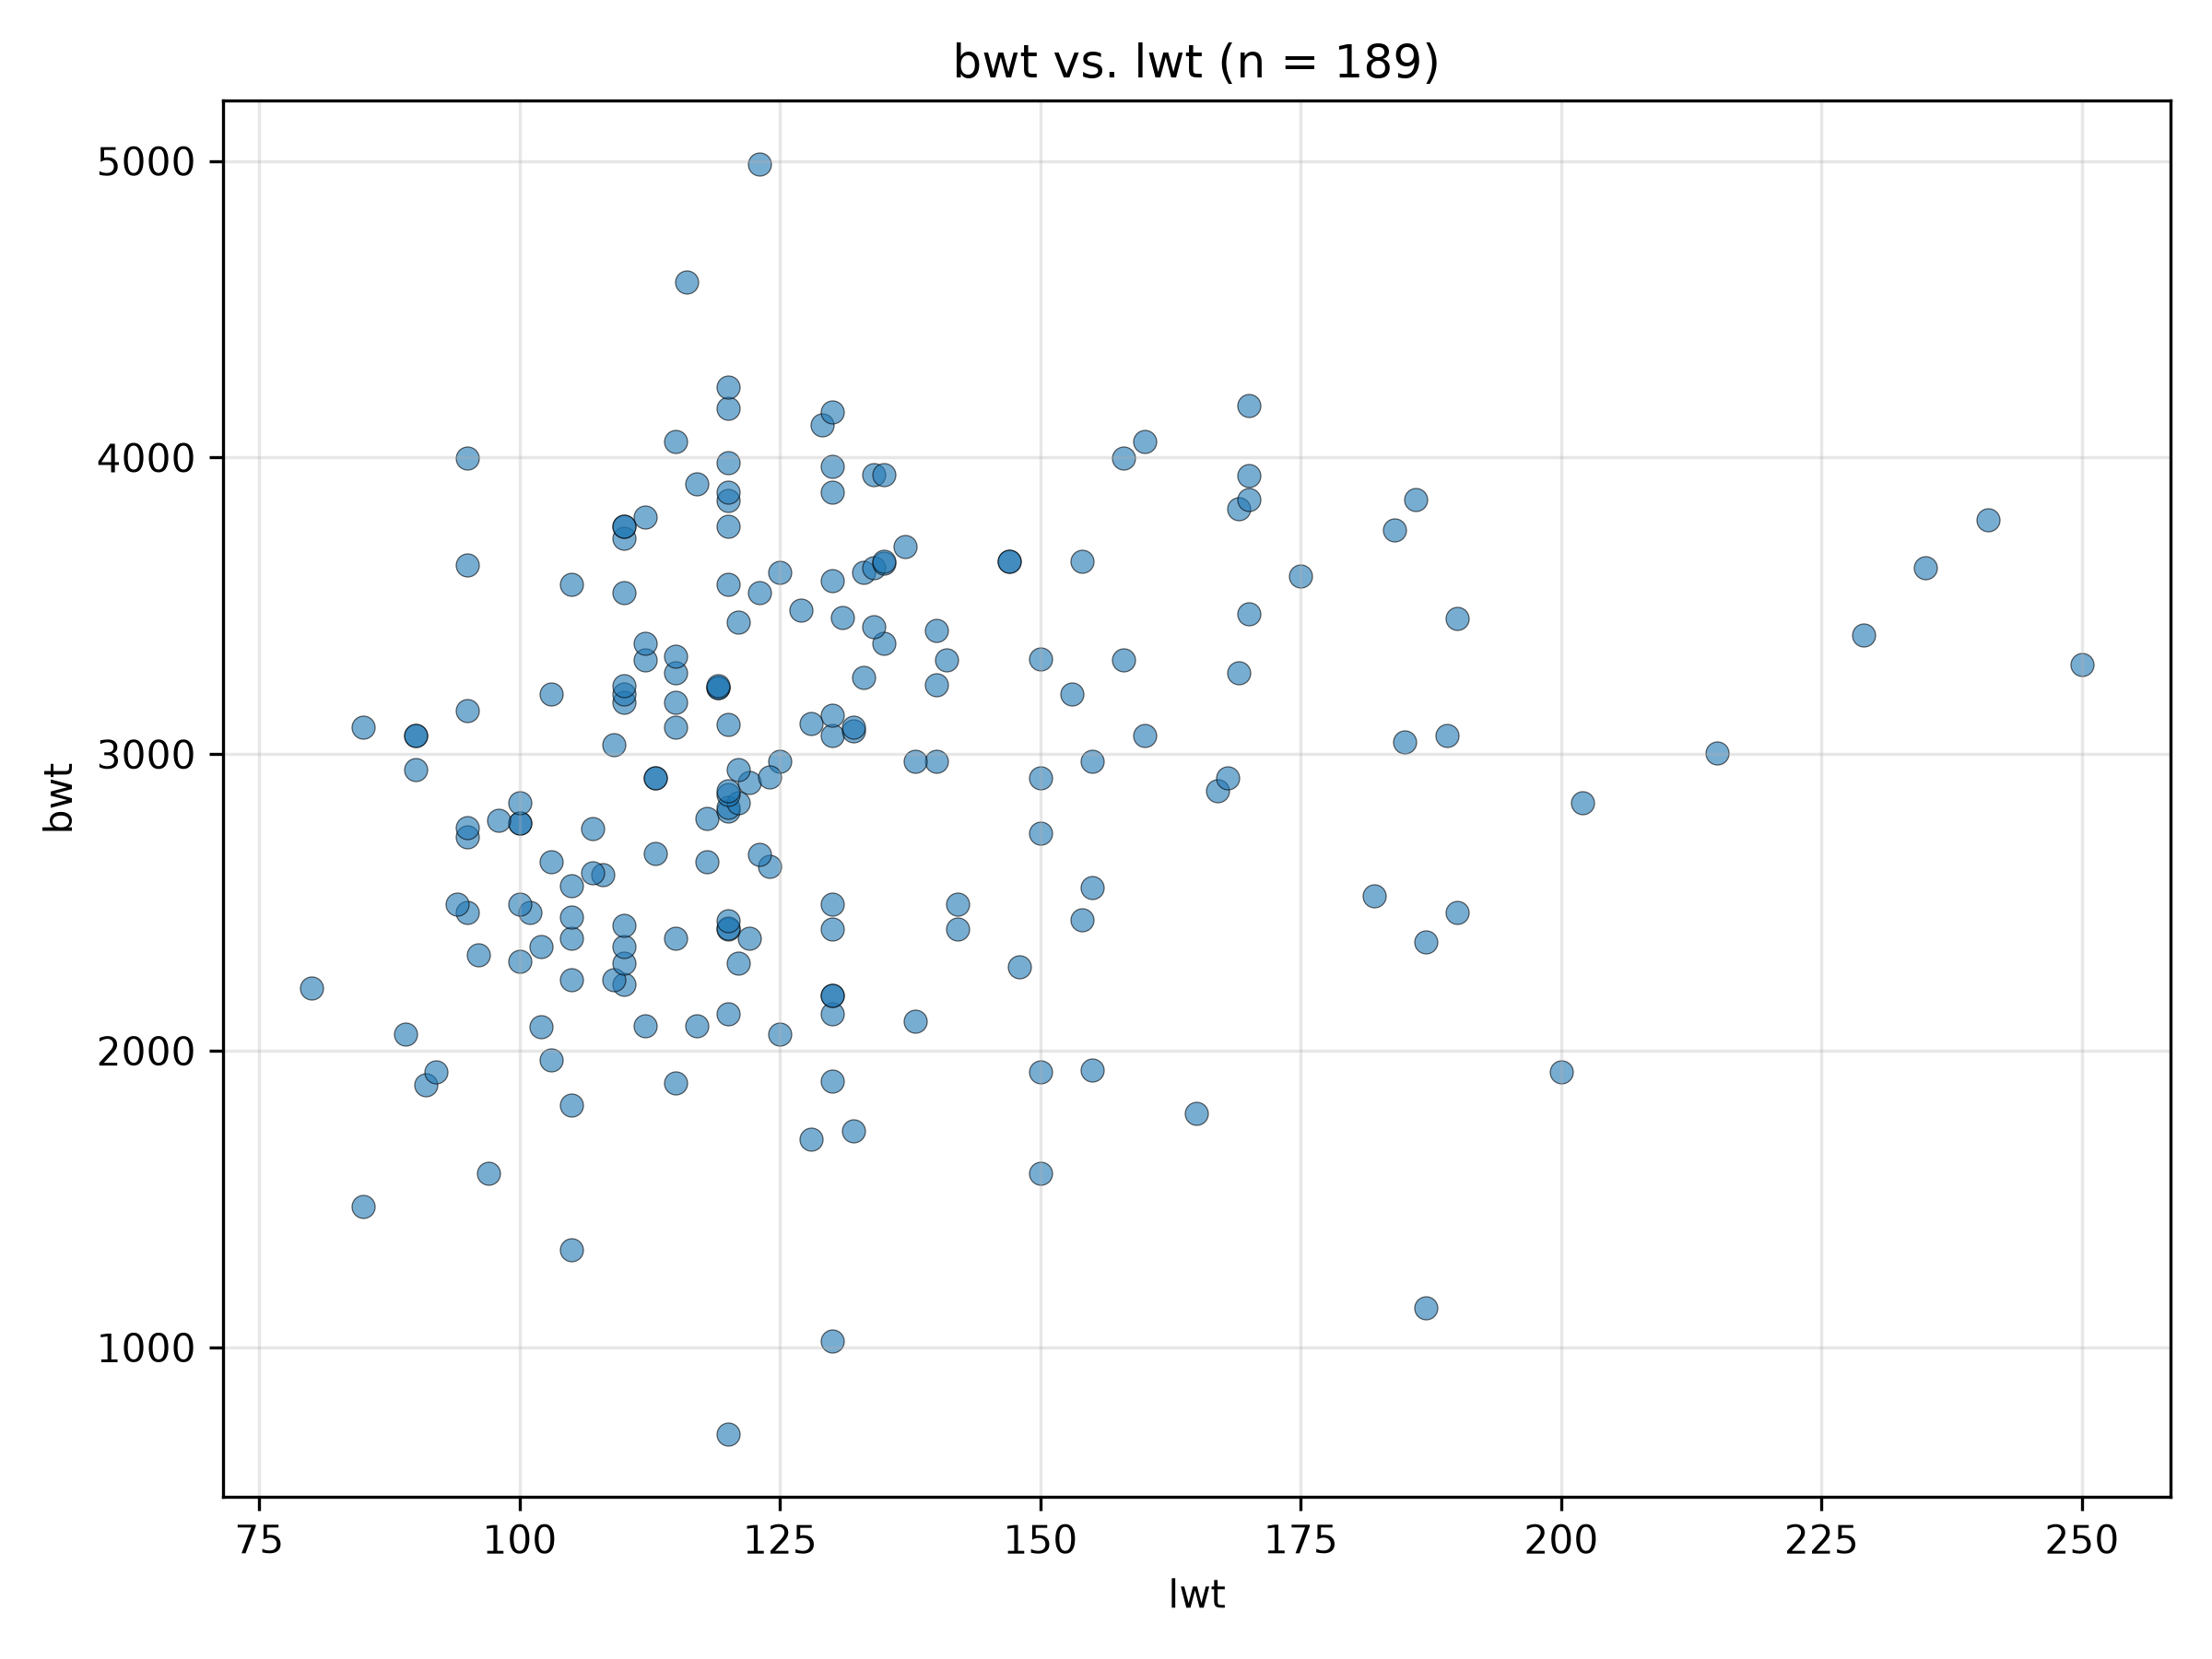

Figures 1 & 2: Mother's Weight and Birthweight
Independent Variable (X): lwt Mother's weight in pounds
Dependent Variable (Y): bwt Baby's birthweight in grams
β₀ (Intercept): 2369.6235
β₁ (Slope): 4.4291
R²: 0.0345
Interpretation: The scatterplot and regression line show a very weak positive relationship between mother's weight and baby's birthweight. And a predicted increase of approximately 4.43 grams in birthweight for each additional pound of maternal weight.

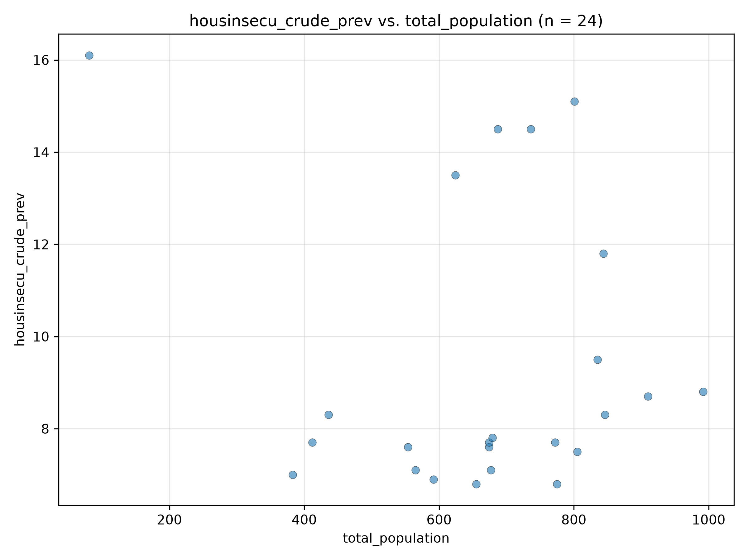
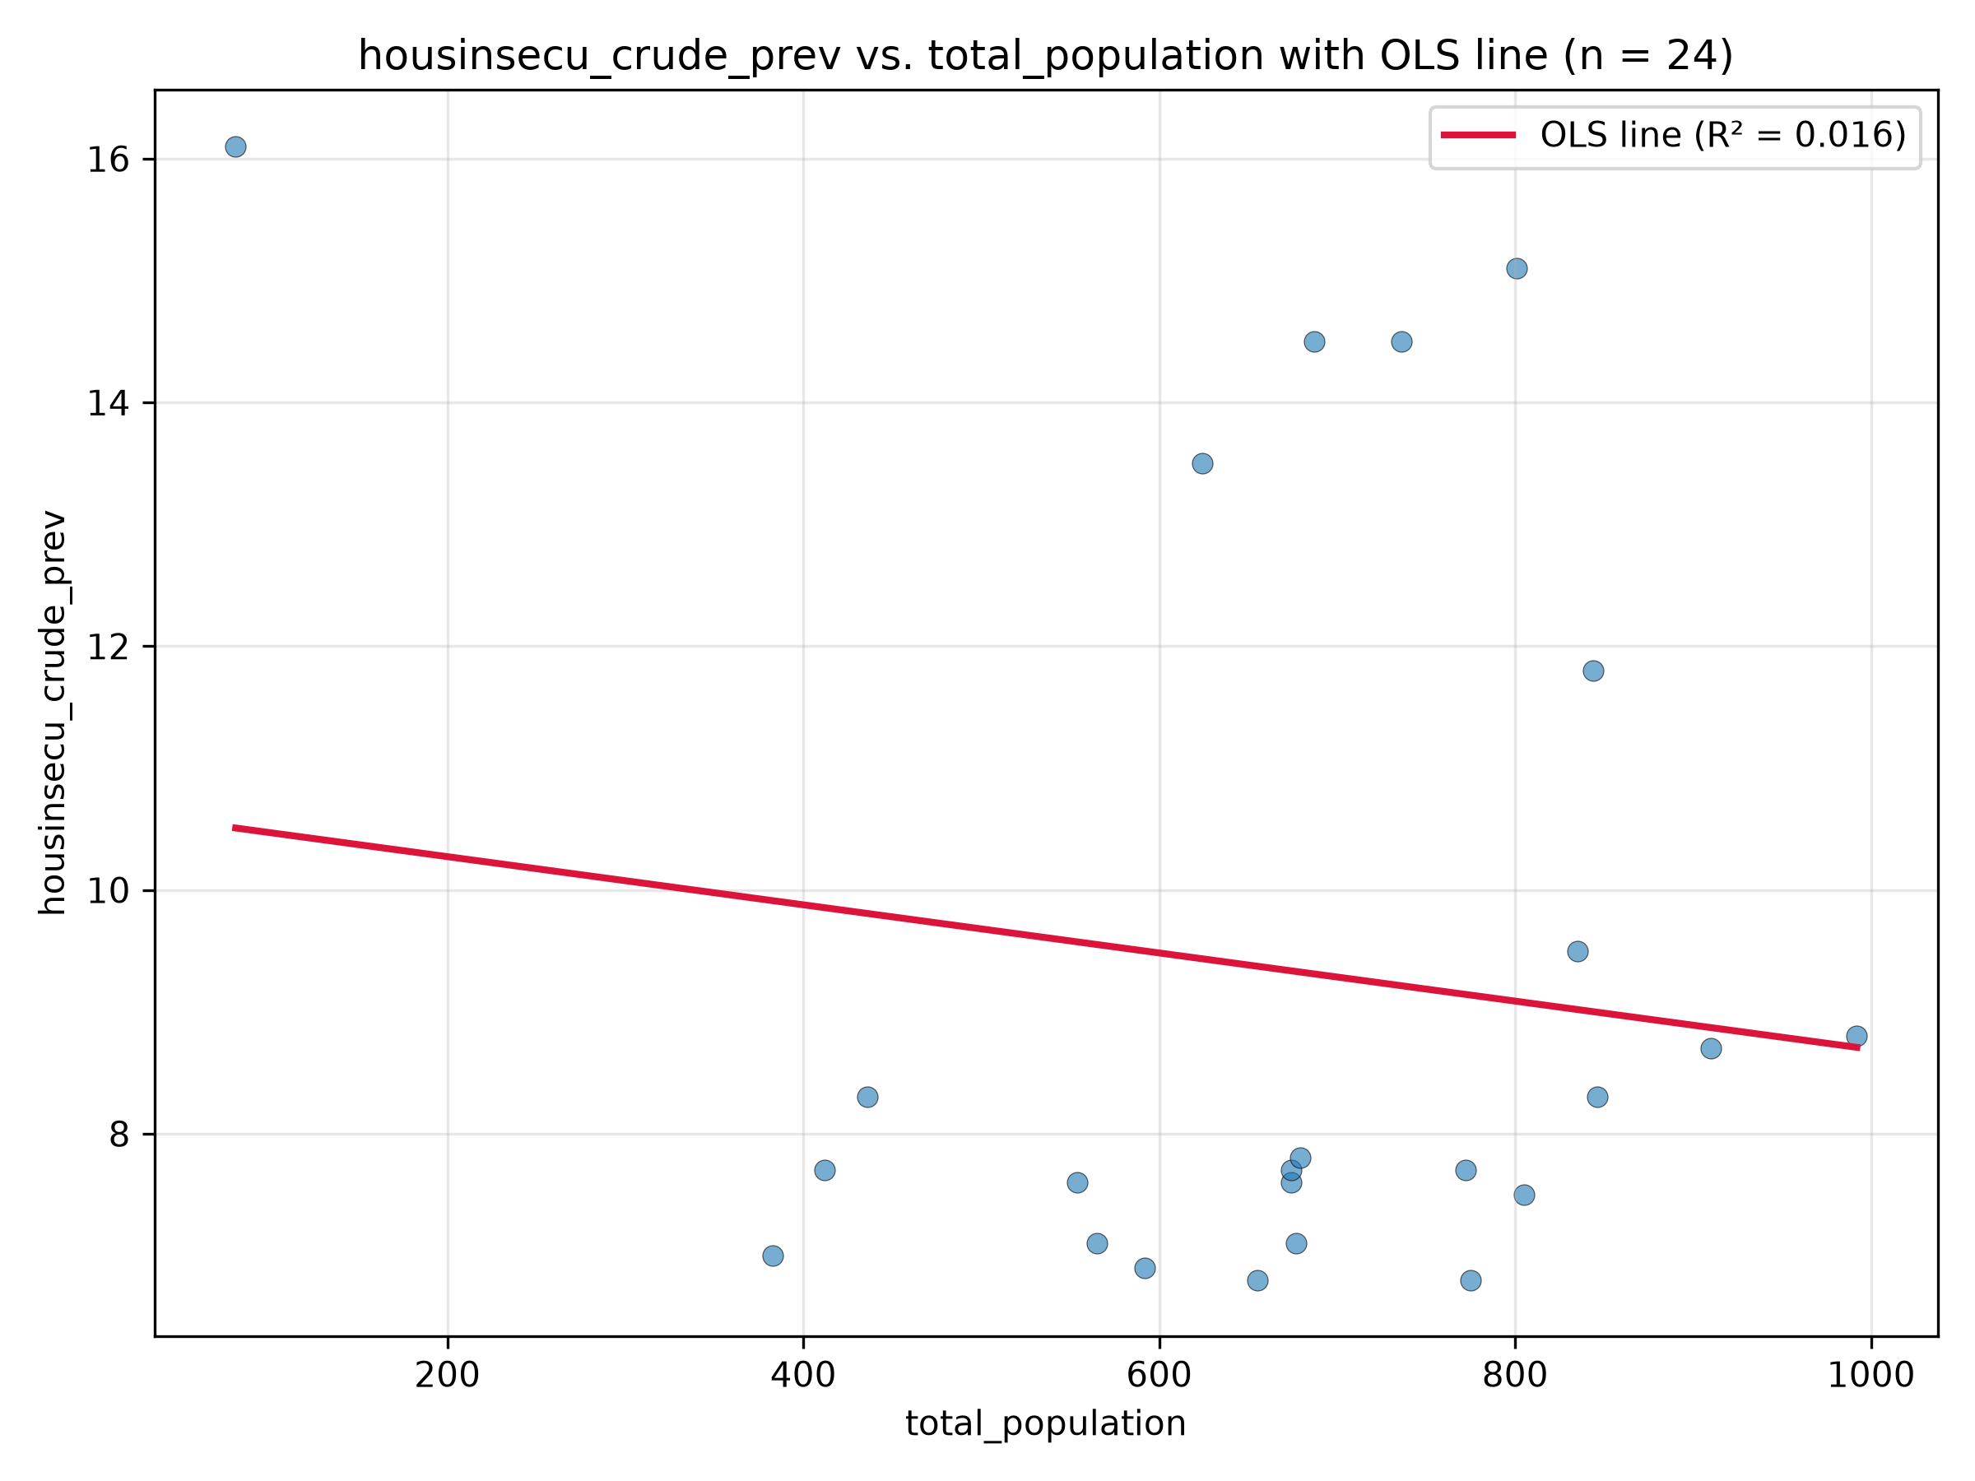
Figures 3 & 4: Housing Insecurity and Total Population
Independent Variable (X): total_population Total population
Dependent Variable (Y): housinsecu_crude_prev Housing insecurity prevalence (%)
β₀ (Intercept): 10.6677
β₁ (Slope): -0.0020
R²: 0.0164
Interpretation: The scatterplot and regression line show a very weak negative relationship between total population and housing insecurity prevalence. The negative slope indicates that housing insecurity prevalence slightly decreases as total population increases. The R² value of 0.0164 means that total population explains only 1.64% of the variation in housing insecurity prevalence. The slope of -0.0020 indicates a predicted decrease of approximately 0.002 percentage points in housing insecurity prevalence for each additional unit of total population, although the relationship is very weak.

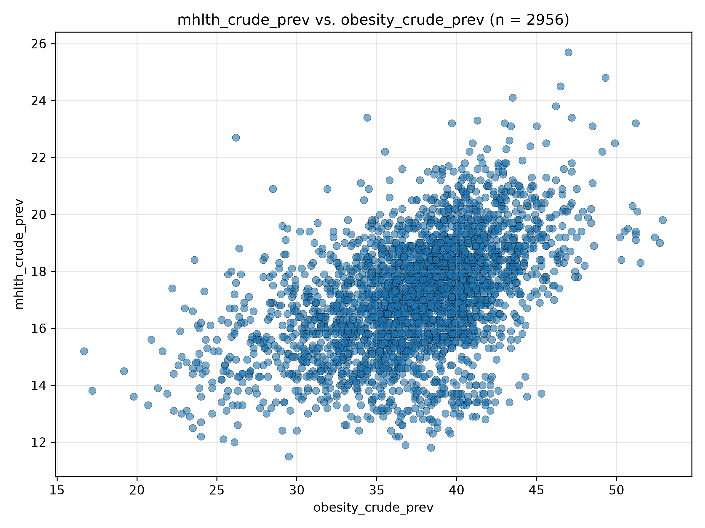
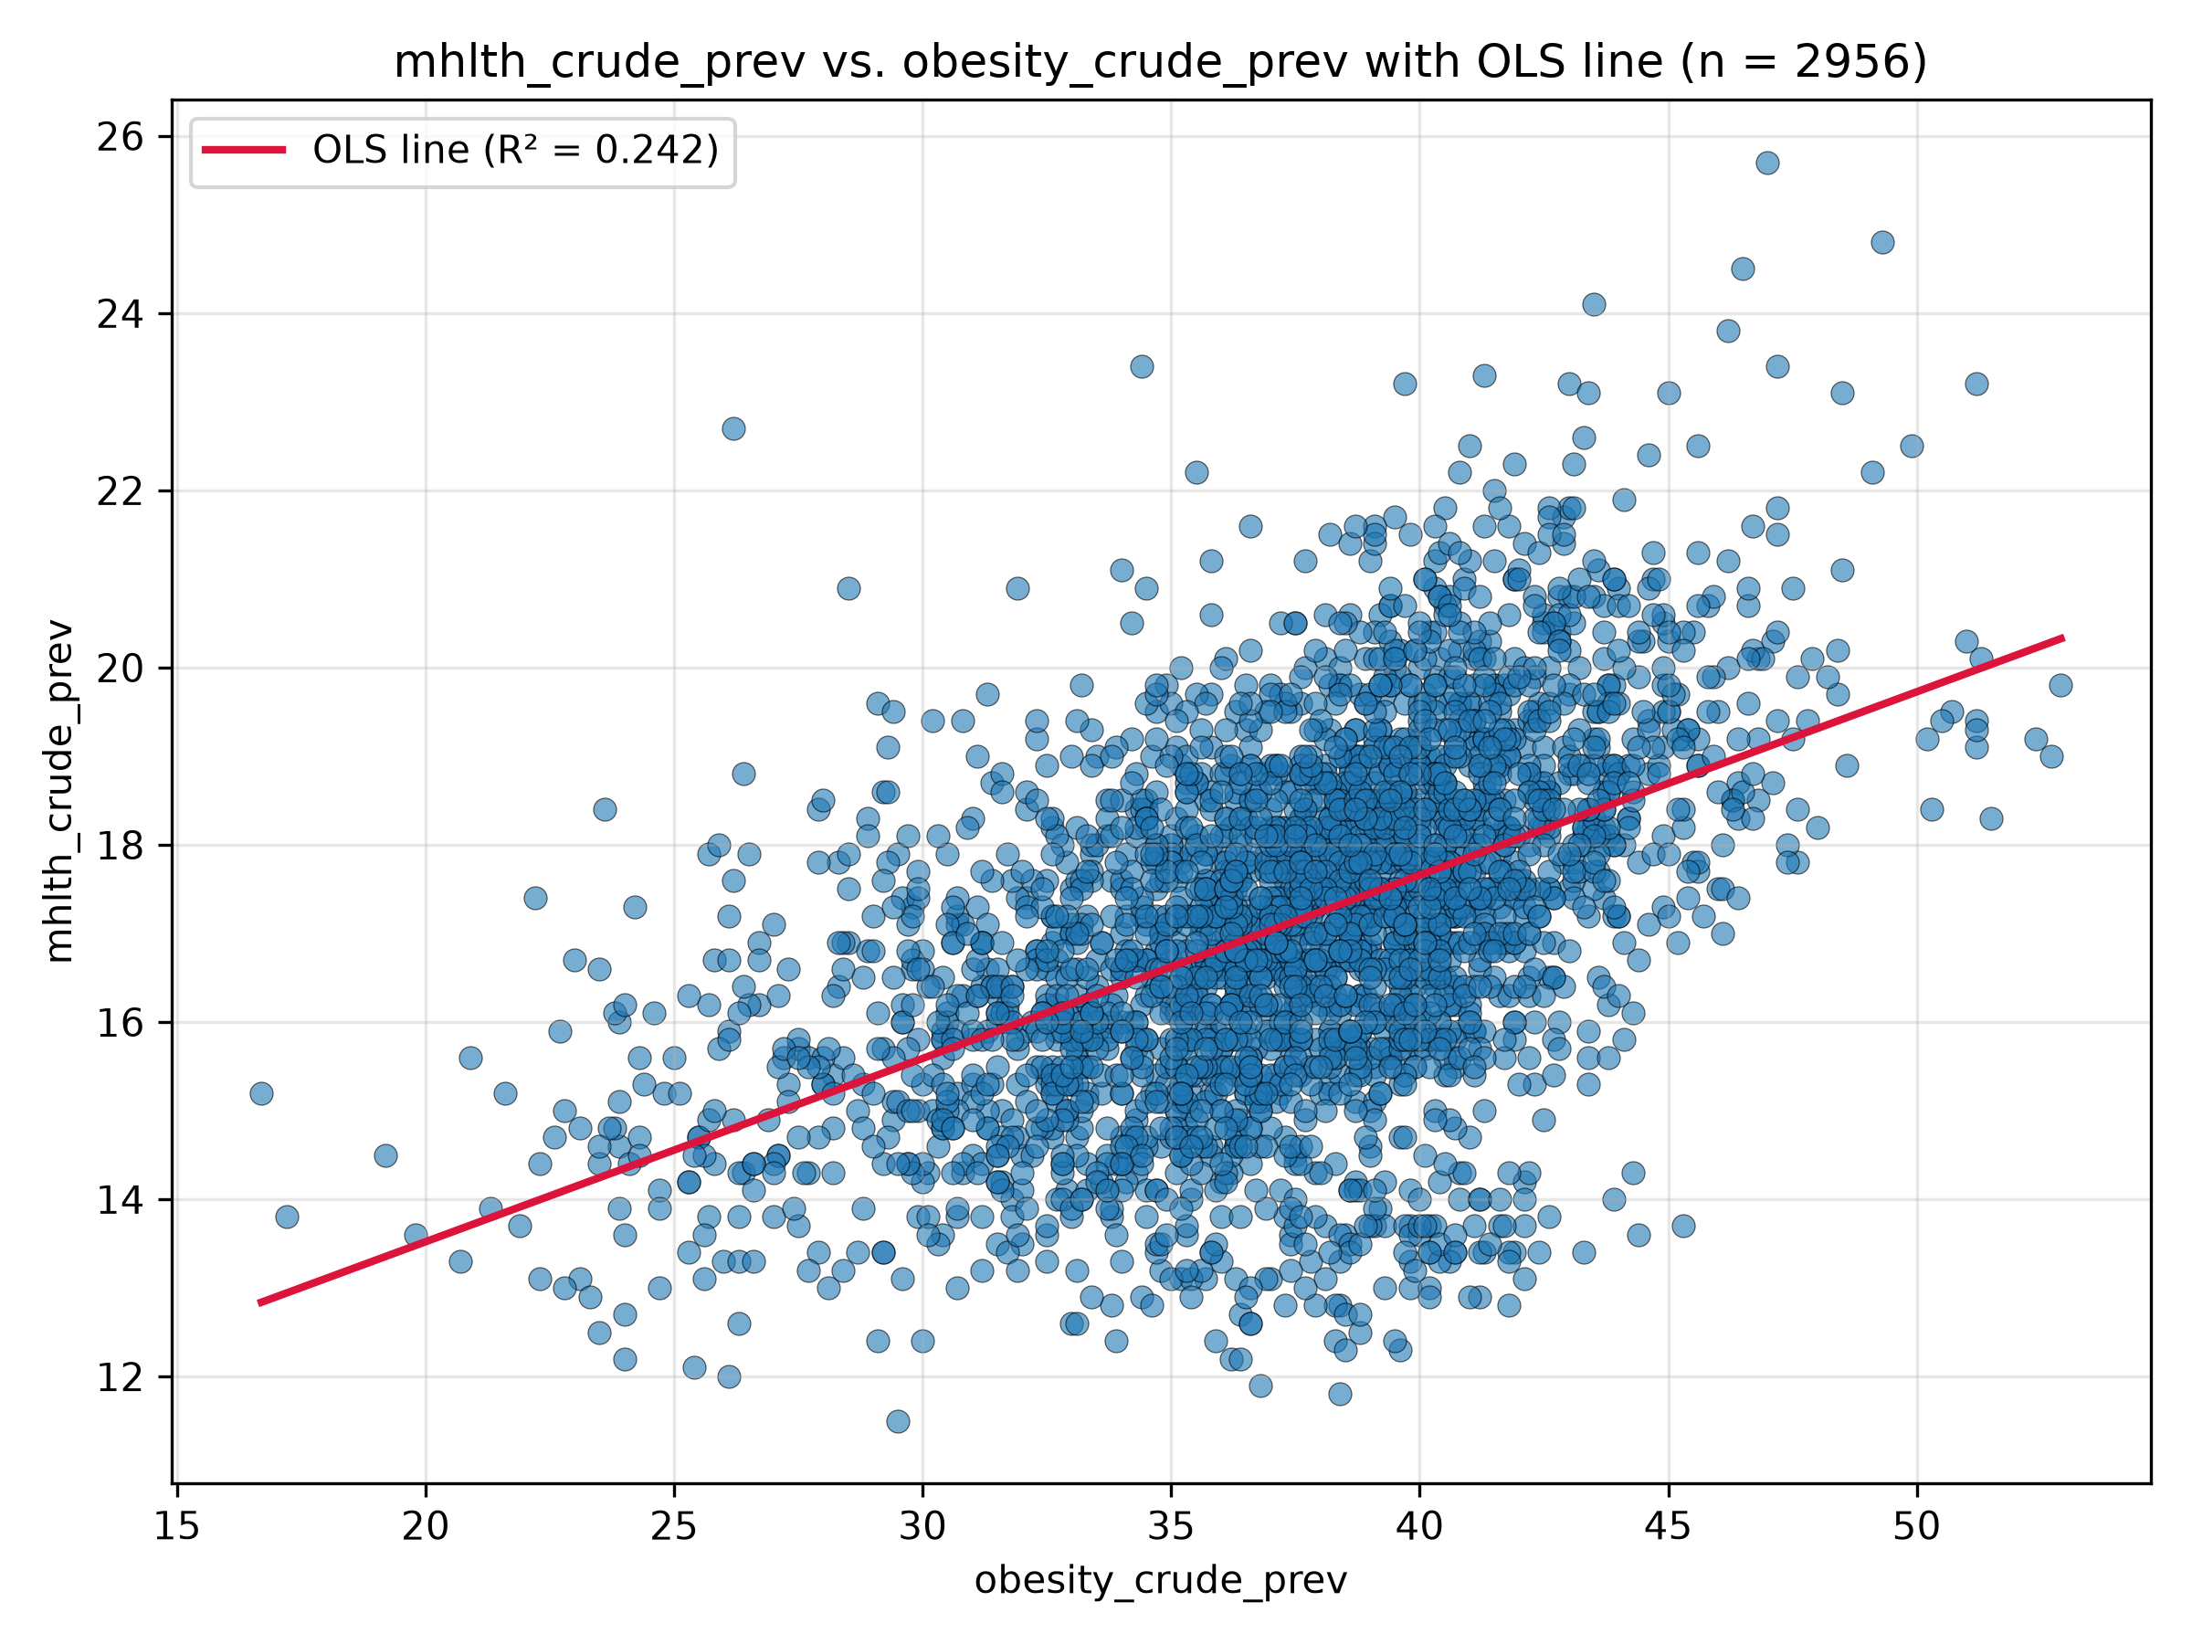
Figures 5 & 6: Obesity and Mental Health Disorders
Independent Variable (X): obesity_crude_prev Obesity prevalence (%)
Dependent Variable (Y): mhlth_crude_prev Frequent mental distress prevalence (%)
β₀ (Intercept): 9.3830
β₁ (Slope): 0.2069
R²: 0.2418
Interpretation: The scatterplot and regression line show a positive relationship between obesity prevalence and frequent mental distress. The slope indicates a predicted increase of approximately 0.21 percentage points in frequent mental distress prevalence for every 1 percentage point increase in obesity prevalence. The R² value of 0.2418 indicates that obesity prevalence explains approximately 24.18% of the variation in frequent mental distress prevalence.

